Navida, Vincenzo Roberto

Banglagan, Kevin

Wireframe for Rock, Paper, Scissors Game

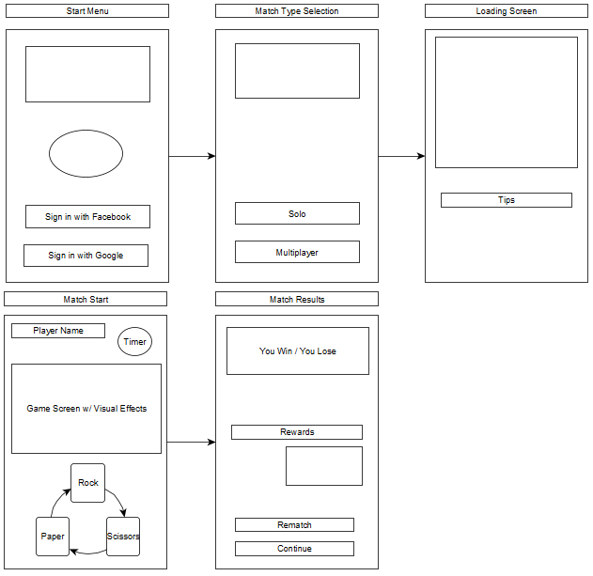

Mockup for Rock, Paper, Scissor Game

